Module 4 – Basic Organization Designs

Module Objectives
- Explain what is meant by organizational structure and design
- Describe the elements of organizational design
- Differentiate mechanistic and organic organizational structure
- Describe the contingency variables that could affect the organizational structure

Organizational Design and Structure :
- Managers need to establish structural designs that will best support and allow employees to do their work effectively and efficiently.
- Organizing is arranging and structuring work to accomplish the organization’s goals.
- Organizational structure is the formal arrangement of jobs within an organization. It is the linking of departments and jobs within an organization.
- Organizational design is developing or changing an organization’s structure.

Purpose or Reasons for Organizing:
- Divides work to be done into detailed jobs and departments
- Assigns tasks and responsibilities related with individual jobs
- Coordinates different organizational tasks
- Creates relationships among individuals, groups, and departments
- Creates formal lines of authority
- Assign organizational resources

Elements of Organizational Design
ELEMENTS OF ORGANIZATIONAL DESIGN
Work Specialization
Formalization
Centralization/Decentralization
Departmentalization
Chain of Command
Span of Control

Elements of Organizational Design :
1. Work Specialization is the degree to which tasks in an organization are divided into separate jobs.
- Job is not done by one individual. It is broken down into steps, and a different person completes each step.
- Individual employees specialize in doing part of an activity rather than the entire activity.

2. Departmentalization:
- It is the basis by which jobs are grouped together.
- Every organization has its own specific way of classifying and grouping work activities.
- Forms of Departmentalization:
  - Functional
  - Product
  - Geographical
  - Process
  - Customer

A. Functional Departmentalization :
- It groups jobs by functions performed.
- It can be used in all kinds of organizations;
- It depends on the goals each of them wants to achieve.
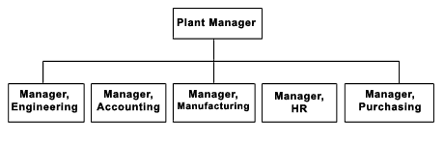

B. Product Departmentalization :
- It groups jobs by product line.
- Each manager is responsible of an area within the organization depending of his/her specialization.
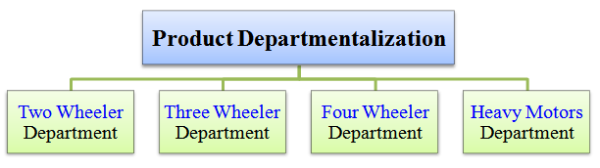
C. Geographical Departmentalization:
It groups jobs on the basis of territory or geography.
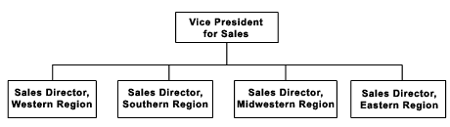

D. Process Departmentalization:
It groups activities or jobs on the basis of product or customer flow.
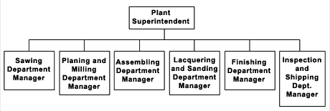

E. Customer Departmentalization:
It groups jobs on the basis of common customers.
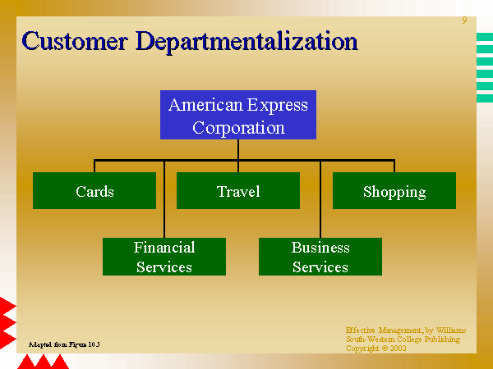
3. Chain of Command:
- It is defined as a continuous line of authority that extends from upper organizational levels to the lowest levels and clarifies who reports to whom.
- There are three important concepts attached to this theory:
- Authority: Refers to the rights of a manager to tell people what to do and to expect them to do it.
- Responsibility: The responsibility to perform any assigned duties.
- Unity of command: The management principle that each person should report to only one manager.
Chain of Command
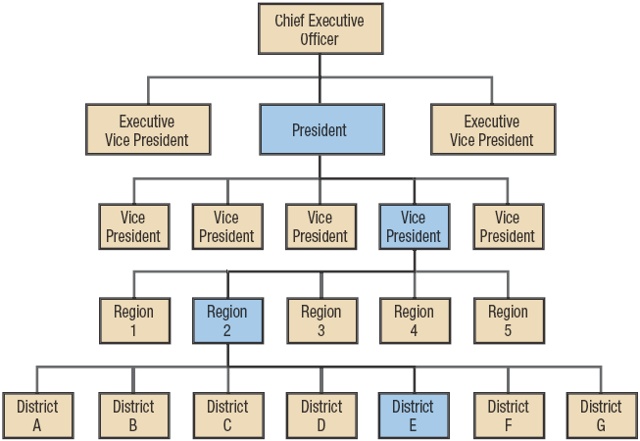

4. Span of Control:
- It determines the number of levels and managers an organization has.
- Also, it determines the number of employees a manager can efficiently and effectively manage.

Span of Control

5. Centralization and Decentralization:
Centralization: means that authority is concentrated at the top level of management. In other words, centralization is a situation in which top management retains most of the decision making authority.
Decentralization: means that decision making is distributed among all levels of the organization. This means that information is shared from the top of management downwards.
6. Formalization : It refers to the degree or measure to which jobs within the organization are standardized (the same) and employee behavior is guided by rules and procedures.

Types of Organizational Structure :
A. MECHANISTIC ORGANIZATIONAL STRUCTURE : A structure that is high in specialization, formalization, and centralization. It is called “bureaucracy”.
B. ORGANIC ORGANIZATIONAL STRUCTURE : A structure that is low in specialization, formalization, and centralization. It is called “adhocracy”.
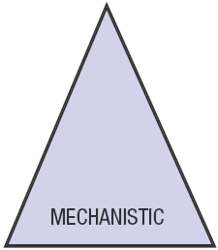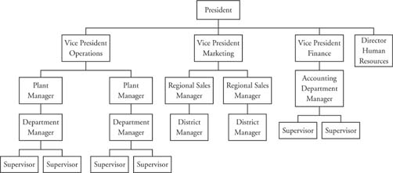
- Employees work separately (one-by-one) and specialize on one task or activity.
- Many rules
- Much on written communication
- Centralized decision authority
- Taller structures
STRATEGIES:
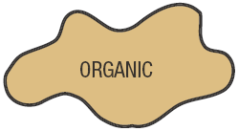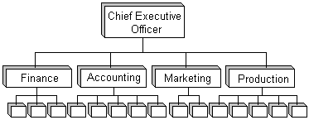
- Employees work together and coordinate tasks
- Few rules
- Much on verbal communication
- Decentralized decision authority
- Flatter structures
STRATEGIES:
Contingency Variables :
- Contingency variables are factors that could affect the organizational structure.
- These factors are:
  - STRATEGY – creating new plan or change of plan
  - SIZE – increasing or decreasing the number of employees
  - TECHNOLOGY – using a new technology

